20150920 Arduino and Lithium Ion Batteries - Don’t Burn Down The House, Yet!

Update: October 25 - No Fires, No Problems Yet. Size was a suprise (larger than AA)

We will be sharing the info on my project to use Lithium Ion batteries in the Bitty Rover platform.

Topics:

Problems with Lithium Ion Batteries

1. Shipping limitations - contact shipper when shipping Lithium Ion Batteries
2. Explosion/Fire Hazard (read warnings with batteries, check battery overload/overchare warnings).
3. The smallest voltage you can get is 3.7V. The 18650 Lithium Ion rechargeable is much larger than a AA battery. You get more power, but a larger footprint.
4. You will need a 3 battery pack to power an arduino (for about 12V). 4.2 volt max/3.0 Min
5. There are a LOT of bogus batteries being sold. Stay at 3600 MaHours max. Anything above this is probably BOGUS.
6. Follow the Grand Poo Bah (the only with more money than sense, at this point). Besides he is very entertaining (to watch).

Do not buy this stuff yet!

See if Jim’s house burns down first.

I read the reviews on Amazon an bought these (a lot were bad). Gentlemen place your bets!

Initilal test:

9/20 batteries were charge with the charger supplied with them (2 cell). (not the 4 unit charger). 9/21 3 unit battery holder came in. Installed 3 unit lithium battery box in bitty rover, and it screams (compared to 5 AA batteries). Significant loss of traction (wheels spin so fast they have trouble catching up). Remember there are still safety issues here.

**TangsFire 4pcs 18650 3600 mAh 3.7V Li-ion Rechargeable Battery + Charger + Box**

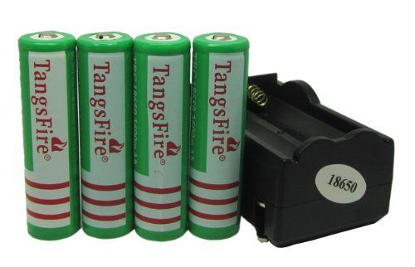

**2014 New Version Nitecore I4 V2 Intelligent Charger for NiMH NiCD Li-ion Battery - Pretty crude device! READ INSTRUCTIONS IF YOU PLAY WITH THIS UNIT!!!! DO NOT BUY THIS UNTIL YOU CONFIRM POO’S HOUSE DID NOT BURN! IF YOU HATE YOURSELF, THIS MAY BE THE UNIT FOR YOU. (If you are reading Poo’s stuff, you probably ain’t the sharpest tool anyway).**

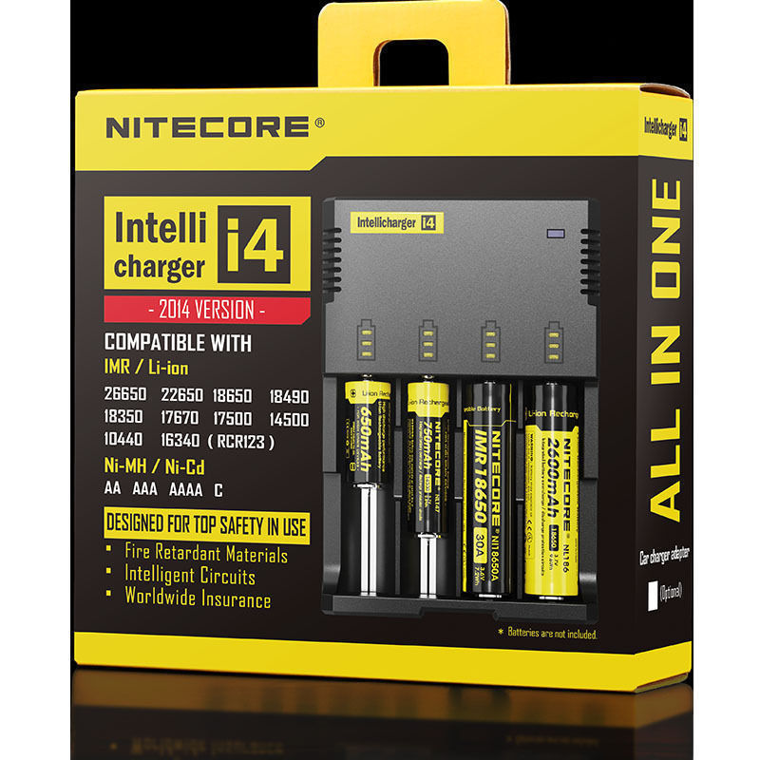

**Battery Storage Case Box Holder for 3 x 18650 Black with 6" Wire Leads USHF**

